**机试题**

**题目1：矩阵的乘法运算**

#include<stdio.h>

#include<stdlib.h>

#include<time.h>

main()

{

int i, j;

int(*p)[3];

int a[4][5], b[5][3];

int* ch(int a[][5], int b[][3]);

/*首先进行随机数的生成*/

srand((unsigned)time(NULL));

/*以下输出数组A*/

printf("生成数组a如下：\n");

for (i = 0; i < 4; i++)

{

for (j = 0; j < 5; j++)

{

a[i][j] = rand() % 19 + 20;//设置生成20~40内的随机数

printf(" %5d", a[i][j]);

}

printf("\n");

}

/*以下输出数组B*/

printf("生成数组b如下：\n");

for (i = 0; i < 5; i++)

{

for (j = 0; j < 3; j++)

{

b[i][j] = rand() % 19 + 20;

printf(" %5d", b[i][j]);

}

printf("\n");

}

/*下面利用指针为c附上相乘后的值*/

p= ch(a, b);

/*下面输出数组C*/

printf("数组C如下：\n");

for (i = 0; i < 4; i++)

{

for (j = 0; j < 3; j++)

{

printf(" %5d", p[i][j]);

}

printf("\n");

}

}

/*以下编写一个矩阵相乘的函数*/

int *ch(int a[4][5], int b[5][3])

{

int c[4][3];

int(*p)[3];

int i, j, s;

for (i = 0; i < 4; i++)

{

for (j = 0; j < 3; j++)

{

c[i][j] = 0;

for (s = 0; s < 5; s++)

c[i][j] += a[i][s] * b[s][j];

}

}

p = c;

return p;

}

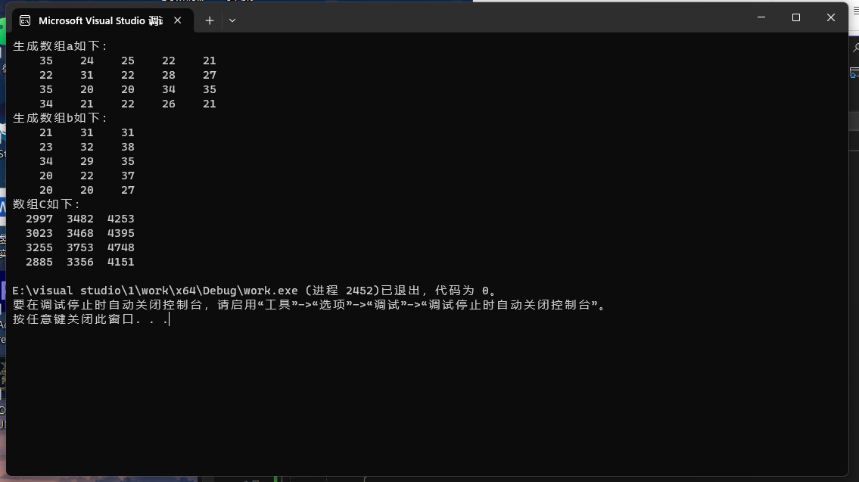

**题目2：日期函数**

#include<stdio.h>

#include<string.h>

main()

{

char str[11];

int l, t;

int tol(char[]);

void new(char[], int);

printf("请输入日期：");

gets(str);

l = strlen(str);//提出日期长度方便判断

/*下面进行输入格式的判断*/

while ((l != 10) || (str[4] != '-') || (str[7] != '-'))

{

printf("请输入日期：");

gets(str);

l = strlen(str);

}

/*调用函数计算对应天数*/

t = tol(str);

printf("对应天数为：\n%d\n", t);

/*再进行日期的移动*/

int n;

printf("请输入n:");

scanf("%d", &n);

new(str, n);

}

/*下面编写一个函数计算天数*/

int tol(char str[])

{

int y, m, d, s = 0, i, flag;

sscanf(str, "%4d-%2d-%2d", &y, &m, &d);

/*首先判断是否为闰年*/

if ((y % 4 == 0 && y % 100 != 0) || (y % 400 == 0))

flag = 1;

else flag = 0;

if (m == 1)//一月直接输出日期

s = d;

else

{

for (i = 1; i <= m; i++)

{

switch (i)

{

case 1: case 3: case 5: case 7: case 8: case 10: case 12:

s += 31;

break;

case 4: case 6: case 9: case 11:

s += 30;

break;

case 2:

s += 28 + flag;

}

}

}

return (s);

}

/*下面编写计算新日期的函数*/

void new(char str[], int n)

{

char str0[11];

int y, m, d, i, flag=1;

int mon[13] = { 0,31,28,31,30,31,30,31,31,30,31,30,31 };

sscanf(str, "%4d-%2d-%2d", &y, &m, &d);

int t = tol(str);

/*移动日期前检查是否为闰年*/

if ((y % 4 == 0 && y % 100 != 0) || (y % 400 == 0))

mon[2] = 29;

else mon[2] = 28;

if (n >= 0)

{

for (i = 1; i <= n&&flag; i++)

{

d += 1;

if (d > mon[m])

{

d = d - mon[m];

m++;

if (m > 12)

{

printf("跨年！\n");

m = 1; d = 1;

flag = 0;

}

}

}

}

else

{

for (i = 1; i <= -n&&flag; i++)

{

d -= 1;

if (d < 0)

{

d = mon[m-1];

m--;

if (m < 0)

{

printf("跨年！\n");

m = 12; d = 31;

flag = 0;

}

}

}

}

/*最后生成字符串*/

sprintf(str0, "%4d-%2d-%2d", y, m, d);

printf("新日期如下：\n");

puts(str0);

}

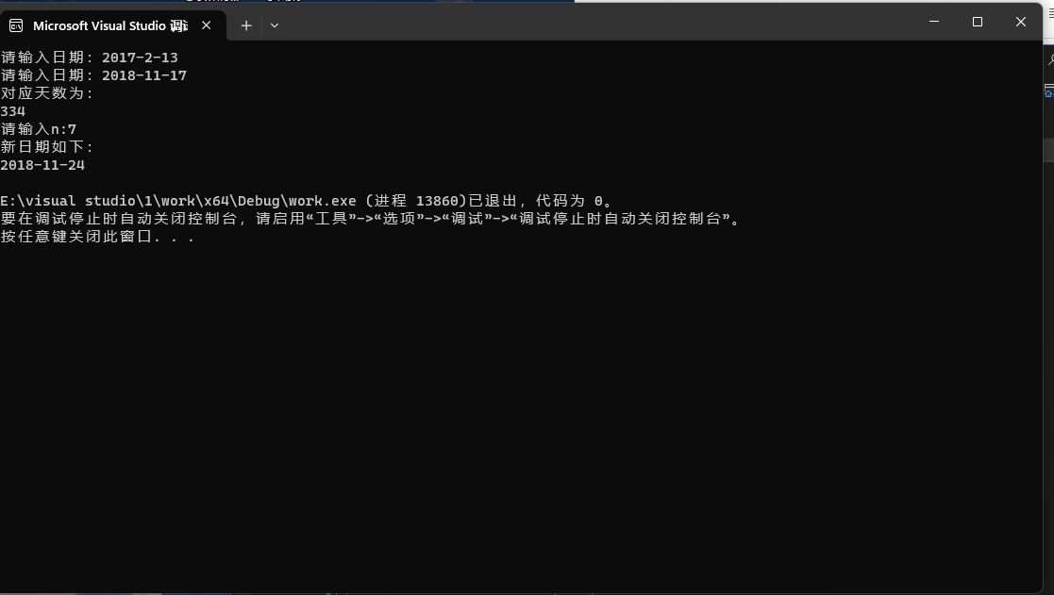

**题目3：用梯形法求sin函数的数值定积分**

#include<math.h>

#include<stdio.h>

double ffts(double a, double b, int n, double eps)

{

int k;

double fa, fb, h, t1, p, s, x, t;

fa = sin(a); fb = sin(b);

h = b - a;

t1 = h*(fa + fa) / 2.0;

p = eps + 1.0;

while (p >= eps)

{

s = 0.0;

for (k = 0; k <= n - 1; k++)

{

x = a + (k + 0.5) * h;

s = s + sin(x);

t = (t1 + h * s) / 2.0;

p = fabs(t1 - t);

t1 = t; n = n + n; h = h / 2.0;

}

return(t);

}

}

main()

{

double a, b, n, t;

printf("请输入积分起点a，积分终点b和分段数n：");

scanf("%lf %lf %lf", &a, &b, &n);

t = ffts(a, b, n, 0.0000001);

printf("定积分为%lf：\n",t);

}

